Bild:

**Editor** Autor**:** *Nicole Yeong*

**Location** Ort: *Taichung*

**Photo** Foto**:** *Nicole Yeong*

**Date** Datum**:** *07/2024*

**Taichung Port: seventh SENNEBOGEN 870 in the fleet**

**The Port of Taichung, situated in central Taiwan, is a key maritime gateway along the East Asian shipping routes. As Taiwan's second largest port, it serves as a crucial regional centre for the shipping and storage of large-scale bulk cargo and operates as an important near-sea container shipping port. Established in the early 1970s, the port has grown exponentially, becoming a linchpin in Taiwan’s maritime infrastructure.**

**A lasting relationship since 2007**

Since October 2006, **Chien Shing Harbour Service** has been operating its ship stevedoring business at Taichung Port. The listed Taiwan-based company is mainly engaged in the provision of integrated logistics solutions, including customs declaration, warehousing, transportation and ship stevedoring. Remarkably, in its second month of operation, Chien Shing achieved 1st place in stevedoring performance at Taichung Port in 2006.

Scrap metal and soil are the two main materials unloaded by Chien Shing’s stevedores. Chien Shing received its first two **SENNEBOGEN 870** material handlers in 2007, working successfully with SENNEBOGEN dealer and service partner, **Capital Machinery Limited**. As the years went by, an additional four 870 machines have been delivered to Chien Shing between 2019 and 2022. The oldest 870 has been in operation for 17 years!

**“We love the SENNEBOGEN 870 because it ensures maximum uptime with its exceptional reliability***”*

When the time came to replace one of their machines, Chien Shing did not hesitate to go with the 870 again.

*"We need to work quickly and productively,"* says John Ko, General Manager of Chien Shing Harbour Service. *We love the SENNEBOGEN 870 because it ensures maximum uptime with its exceptional reliability. We also appreciate the ease of maintenance, as having the same machine makes things more efficient. The 870 is especially suited to our needs and the job site."*

A handover ceremony to celebrate Chien Shing taking possession of their seventh SENNEBOGEN 870 E was held on 3rd July 2024 at Taichung Port.

This specific machine was outfitted with a **14.7m 'banana boom'** and a **13.3m stick** to facilitate its primary task of unloading and loading **scrap metal and soil** from ships. To meet these requirements, two types of orange peel **attachments**—half-open and closed variants—were selected.

**Excellent visibility for high tide at Taichung Port**

In order to accommodate the approximate six-meter tidal difference at Taichung Port, Chien Shing needed a machine that would provide clear visibility at all times. The **Mastercab** with **Skylift 900** and additional **3m tubular pylon** were chosen to give the machine and operator the height needed to get the job done safely.

As the largest cabin in its class, the Mastercab’s all-round-view and large glass floor window provides the operator with the clearest view at all times when unloading ships. Operators have praised the cab for its spaciousness and ergonomic design, which significantly reduce fatigue and enhance their productivity.

**“We have chosen the 870 for its high efficiency and continuous stability”**

Ultimately, the 870 E’s operational efficiency was a decisive factor for Chien Shing. *"Over the years, we have consistently chosen the 870 for its* ***high efficiency and continuous stability****. Additionally, we are extremely satisfied with the service provided by the* ***Capital Machinery team****. Their logistical support is unparalleled,”* says John Ko, General Manager.

**Captions:**

**Header image**

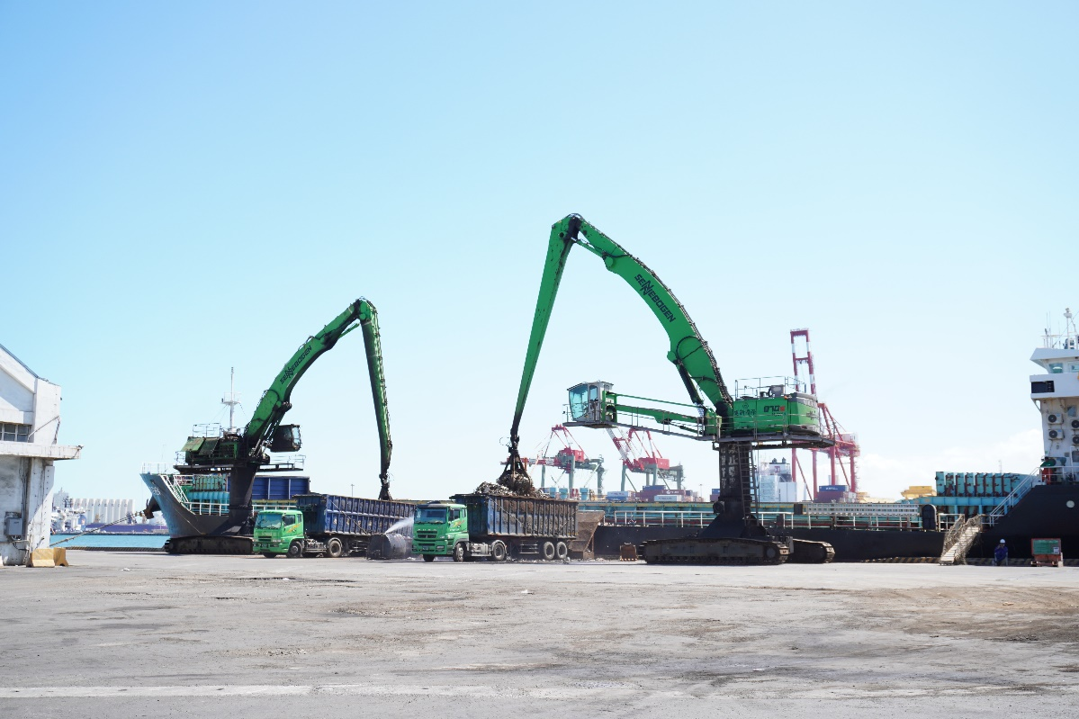

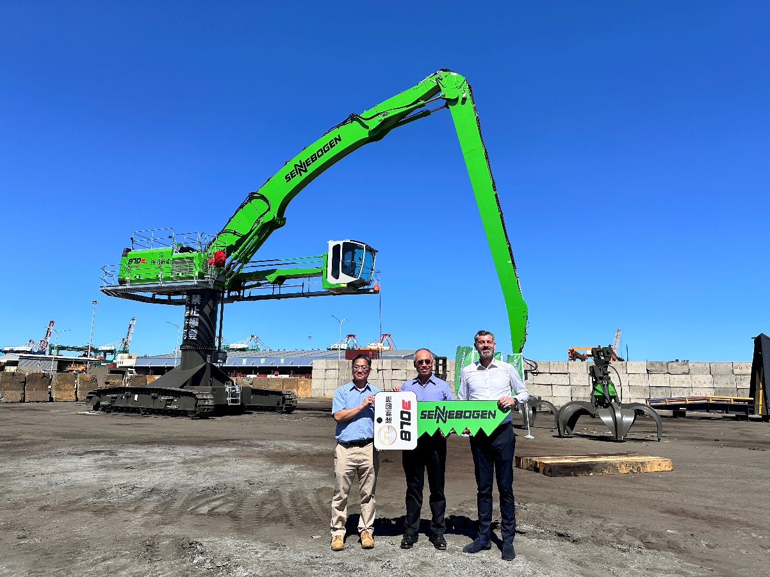

From left to right: Richard Kuok (Head of Machinery Division, Capital Machinery Ltd), John Ko (General Manager, Chien Shing Harbour Service) and Marco Burgmer (SENNEBOGEN Asia Pacific).

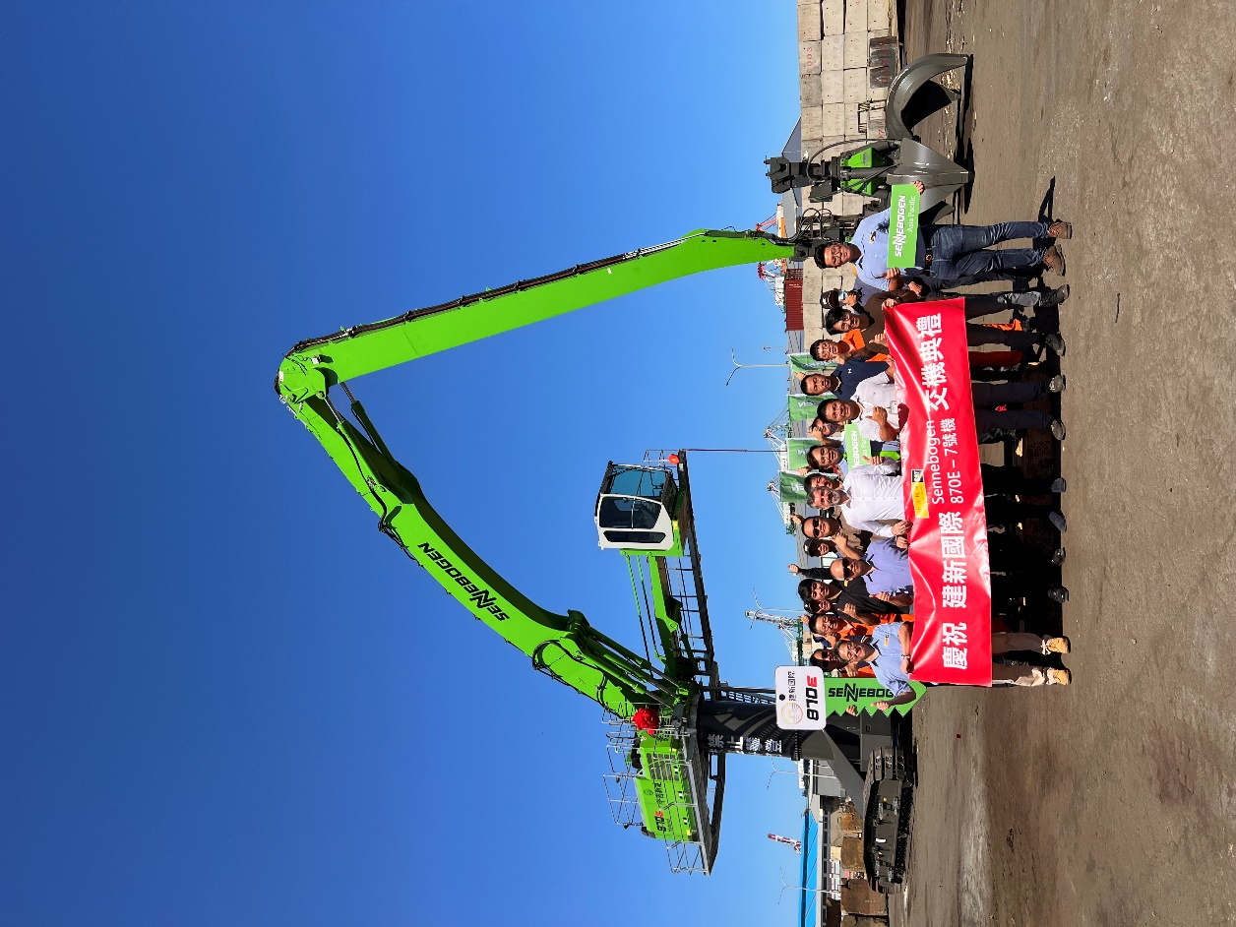

Handover ceremony at Taichung Port that was held on 3rd July 2024.

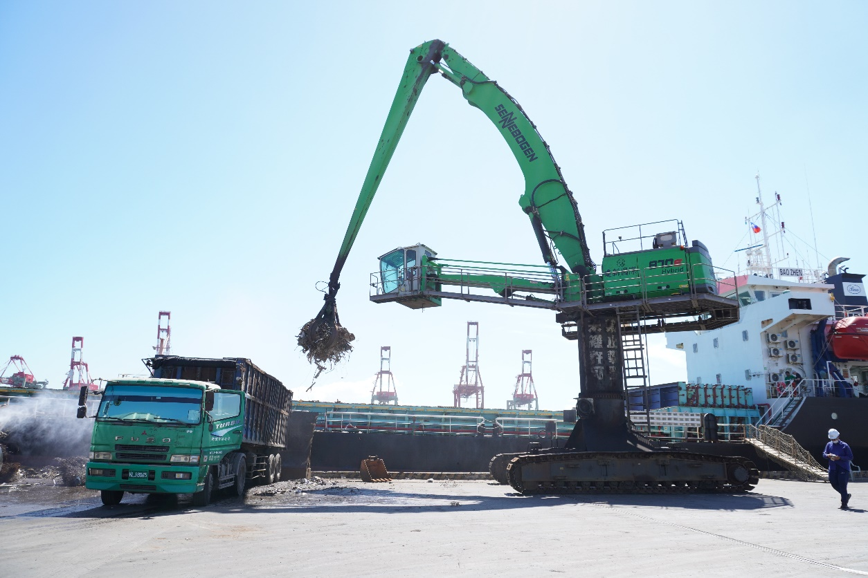

SENNEBOGEN 870 E unloading scrap metal easily from ship to truck.

