Bild:

**Editor** Autor**:** *Nicole Yeong*

**Location** Ort: *Dhaka*

**Photo** Foto**:** *Meer Sadi*

**Date** Datum**:** *02/2025*

**ZERO-EMISSIONS UNLOADING AT FLOUR MILL**

**Ports and jetties worldwide face increasing pressure to boost efficiency while cutting costs and emissions. Located just outside Dhaka in the lively city of Narayanganj, the SENNEBOGEN 855 E is helping Akij Essentials Flour Mills operate at full capacity while keeping an eye on sustainability. As one of the largest flour mills in Bangladesh, Akij Essentials plays a crucial role in the nation’s agricultural and industrial landscape, producing essential food products for households, bakeries, and food manufacturers across the country.**

Akij Essentials Ltd., a division of the Akij Resources conglomerate, is deeply embedded in Bengali tradition and culture, providing a wide range of daily food products like rice, flour, spices, and snacks. Located on the banks of the Shitalakshya River, the mill benefits from efficient transportation of raw materials, making it a central player in Bangladesh’s growing food industry.

**Rapid unloading of grain**

In early 2024, Akij Essentials took a significant step toward sustainability by integrating the fully electric SENNEBOGEN 855 E into their operations, delivered by SENNEBOGEN sales and service partner in Bangladesh, the **Banglamark Group**.

What sets this particular **SENNEBOGEN 855 E** apart is its **12-meter banana boom**, designed for easy access to the deep cargo holds of bulk carriers during loading and unloading. Its **5-meter pylon** elevates the operator’s cab, offering a clear, panoramic view of both the jetty and the vessel’s cargo holds for enhanced safety and operational efficiency.

Unlike conventional diesel-powered models, the 855 E runs on a **200 kW e-electric motor**, delivering zero-emission performance and significantly lowering energy costs—making it a standout choice for sustainable material handling.

Equipped with a SENNEBOGEN light goods shell, this 855 E is designed to handle lighter bulk materials. The **clamshell grab attachment** is specifically tailored for unloading **wheat and corn** from cargo ships at the customer’s jetty.

At the jetty, the machine completes **four unloading cycles per minute**, offloading approximately **250 tons of raw materials per hour**, ensuring a continuous and rapid supply to the mill.

With its advanced design and capabilities, the 855 E addresses key challenges faced by Akij Essentials, such as rising energy costs, stringent emissions regulations, and the need for reliable, continuous operation in demanding environments.

**Cost-effective and eco-friendly**

Akij Essentials chose the SENNEBOGEN 855 E for several reasons, chief among them being its cost-effectiveness. The **fully-electric system** eliminates the need for fuel, significantly reducing operating costs. With fewer moving parts and no diesel engine, maintenance needs are lower, resulting in fewer service intervals and minimized downtime. In fact, savings of up to 50% in operating costs are achievable when compared to traditional diesel-powered material handlers.

**Savings and sustainability in one package**

Beyond cost savings, the electric motor helps reduce environmental impact by eliminating exhaust emissions and harmful gases. With **vibration-free, low-noise operation**, the 855 E also improves operator comfort and extends the machine’s lifespan, offering a smart, long-term investment for the mill.

By choosing the SENNEBOGEN 855 E, Akij Essentials is not only streamlining their operations but also contributing to a cleaner, healthier environment for the community. The result? Powerful, cost-effective material handling that aligns with both economic and environmental priorities.

**Header image:**

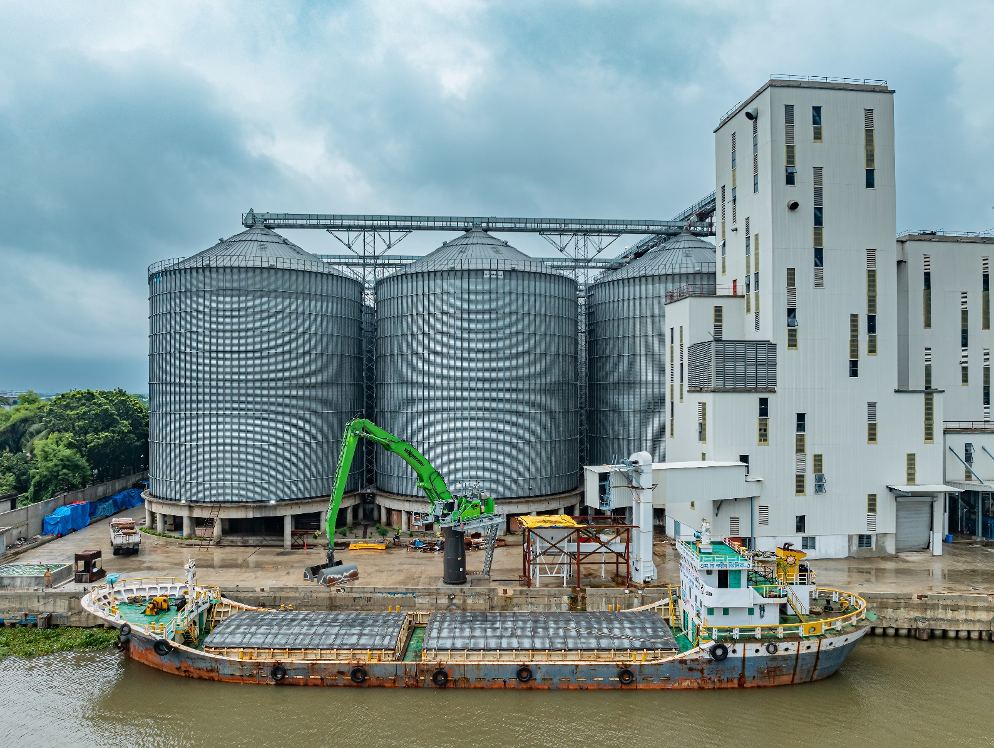

**Captions:**

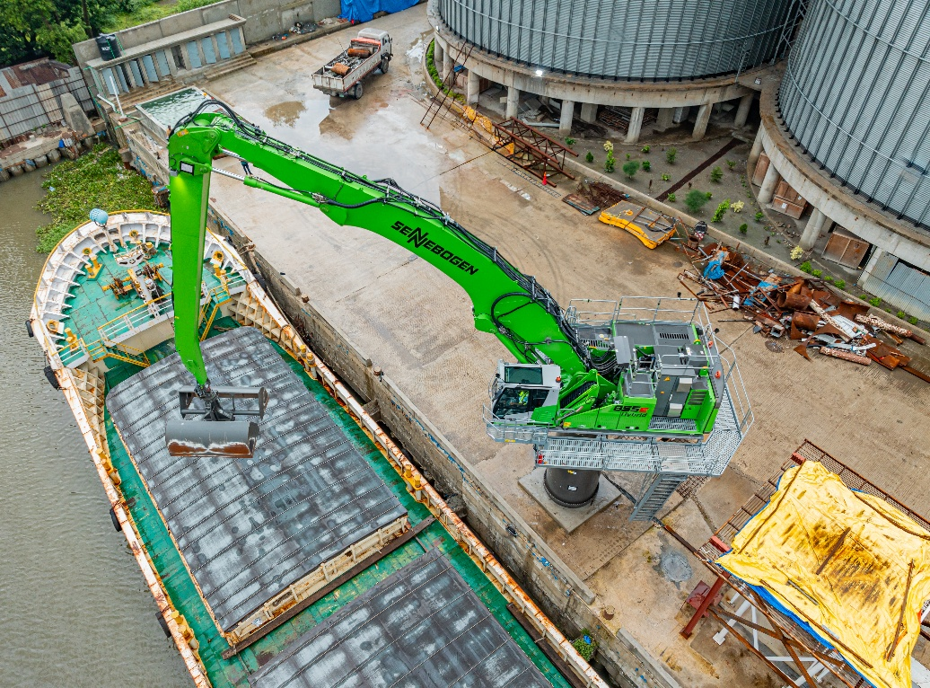

The machine unloads around 250 tons of raw materials per hour with four cycles per minute, ensuring a steady, rapid supply to the mill.

The 12-meter banana boom and 5-meter pylon provide easy access to deep cargo holds and a clear view of the jetty and vessel.

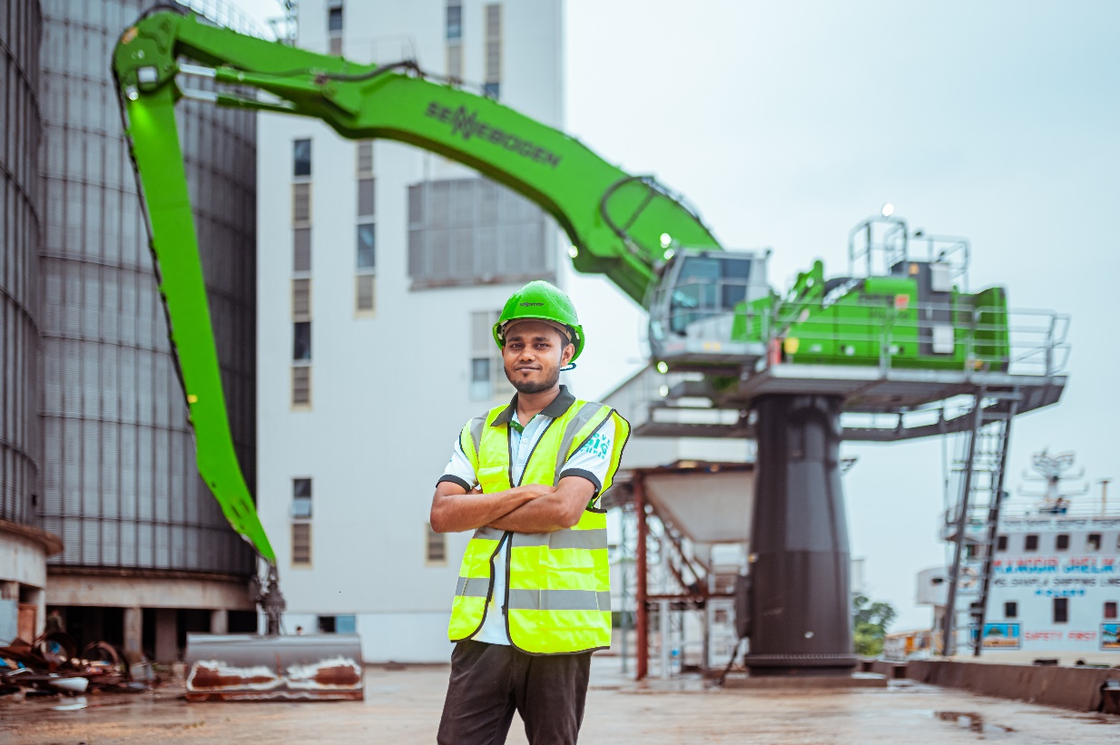

SENNEBOGEN sales and service partner Banglamark, ensures reliable local support and expert service in Bangladesh.